***Human Biology ATAR – Task 4: Science Inquiry - Validation***

***Digestive system (7.5%)***

|  |  |  |  |
| --- | --- | --- | --- |
| Name: | | | |
| Time allowed: 1 Lesson | | | |
| **Section** | Your Mark | Marks available | Percentage |
| **Section 1:**  The journey of food |  | 25 | 50% |
| **Section 2**:  Validation |  | 25 | 50% |
|  |  | **50** | **100%** |

**Declaration of Authenticity**

I (Student Name) _____________________ declare that this work is my own and I have not plagiarised from any source.

Signature:  
  
Date:

1. Finish labelling the following diagram of the digestive system (3 marks)

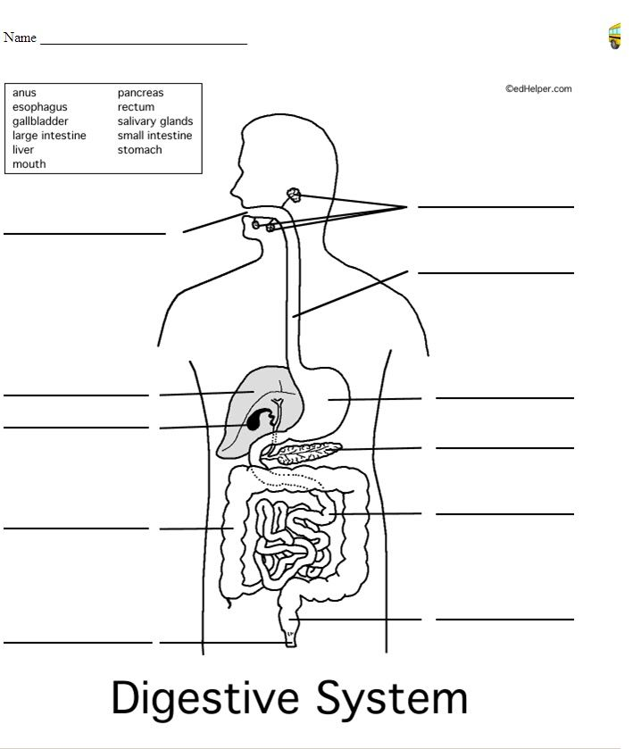

G.

F.

K.

J.

I.

H.

E.

D.

C.

1. Mouth Cavity
2. ___________________________
3. ____________________________
4. Large Intestine
5. Anal Sphincter
6. ___________________________
7. ___________________________
8. Stomach
9. _________________________

J. Small intestine

K. ____________________________

1. **Explain** the role of the following parts of the digestion system on the digestion of food

(14 marks)

|  |  |
| --- | --- |
| **Part** | **Role in digestion of foods** |
| C |  |
| F |  |
| I |  |
| K |  |

1. To be effective, any surface where materials are taken into the body, or passed out of the body must have a very large surface area. Explain how a large surface area is achieved in the part of the digestive system where nutrients are absorbed (4 marks)

_____________________________________________________________________

_____________________________________________________________________

_____________________________________________________________________

_____________________________________________________________________

_____________________________________________________________________

_____________________________________________________________________

_____________________________________________________________________

___________________________________________________________________________

1. Substances that humans eat must be broken down into smaller substances to be absorbed by the human body. Choose one of the following substances and state what enzyme is used to break it down, where this occurs in the digestive system, what it is broken down into, and what it is used for in the body (4 marks)
   * Lipids
   * Proteins
   * Carbohydrates
   * DNA/RNA

_____________________________________________________________________

_____________________________________________________________________

_____________________________________________________________________

_____________________________________________________________________

_____________________________________________________________________

_____________________________________________________________________

_____________________________________________________________________

___________________________________________________________________________

­­­­­­­

___________________________________________________________________________